Prepare Test data by Postgres database in Intelli-J.

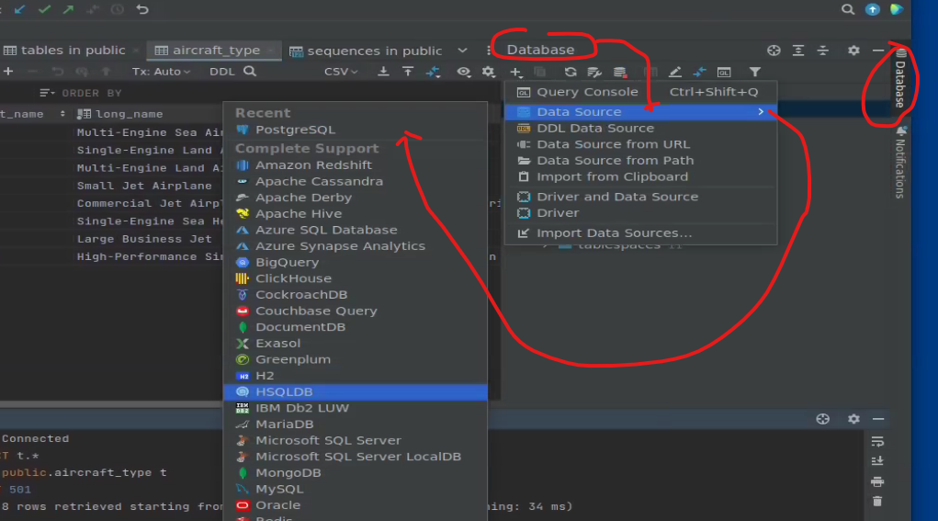

User and Password of Postgres: postgres/postgres

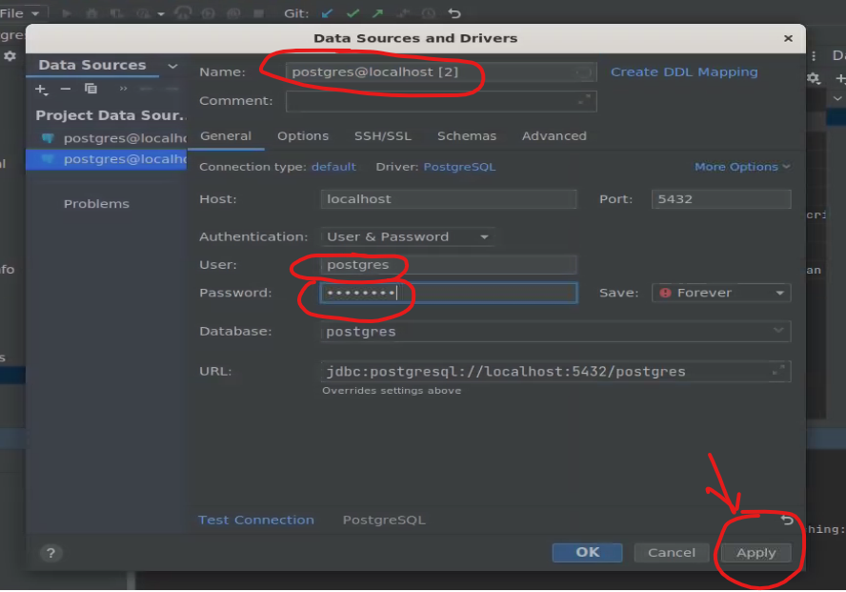

Click Query Console

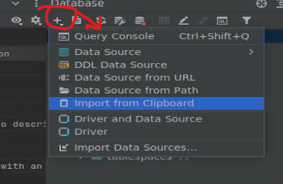

Console displays.

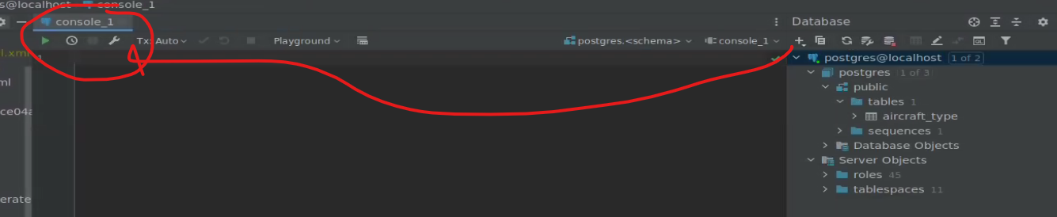

Copy ubuntu-data.sql to Console

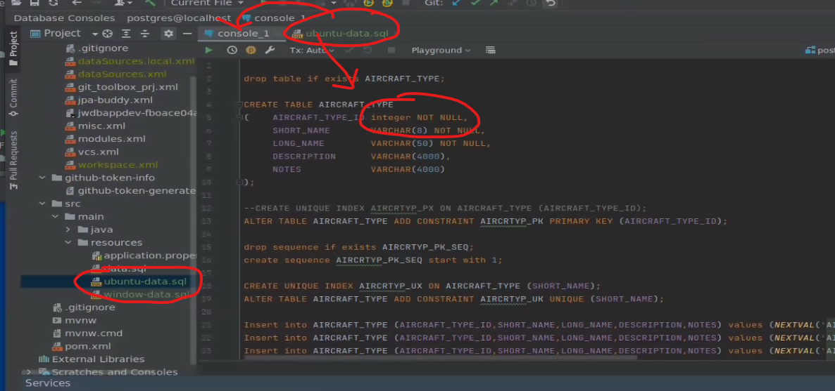

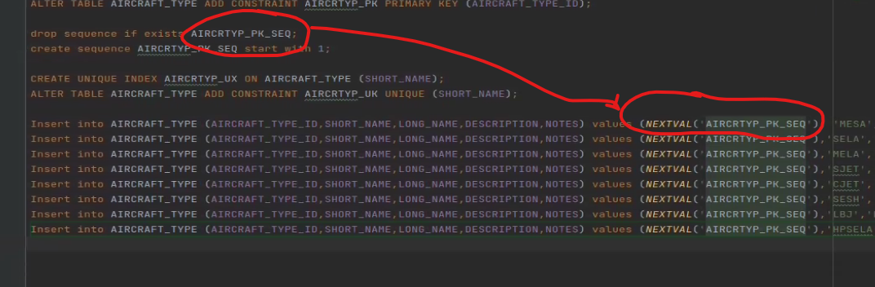

Drop and recreate table and insert data to table.

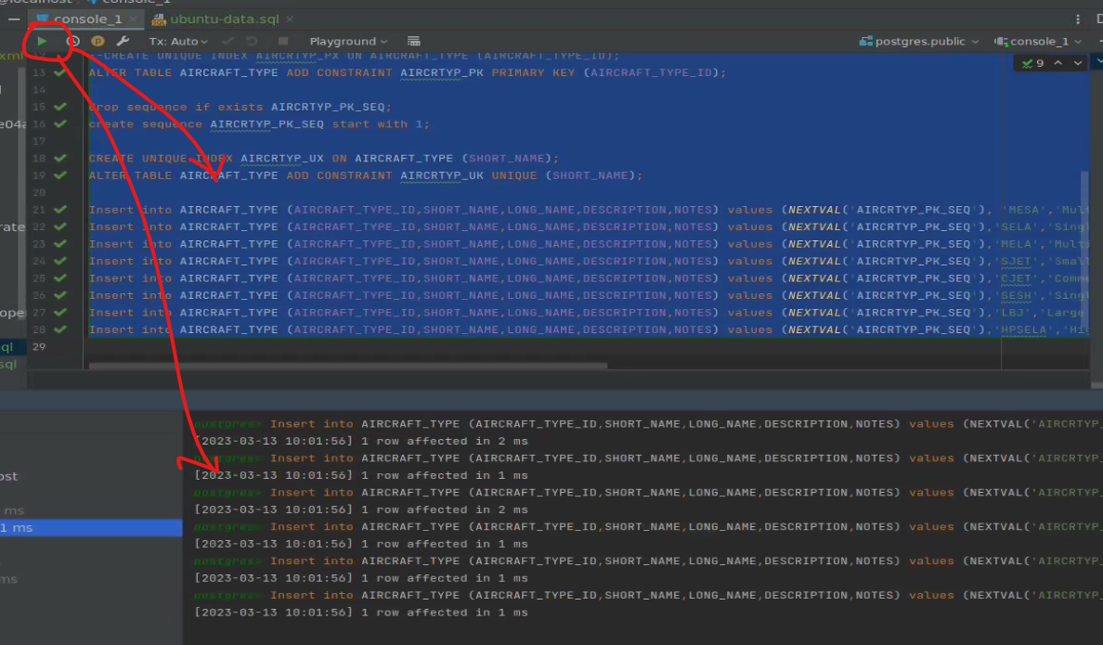

Click Edit Data to view the data in the Table